HYDRAPOWER INSTALLS SHEAR AND CNC PRESS BRAKE AT AMERICAN DOOR CO., BELTSVILLE, M.D.

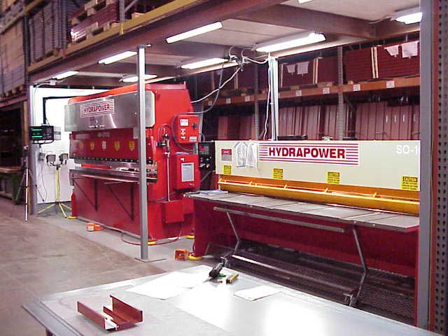

The 10’x70 ton CNC Press brake has a Delem DM54 multi-axis control . The 10’x 10 gauge shear has a Delem DAC 250 CNC Back Gauge and a Front Return system to bring the cut blanks to the front for further processing.

